## Introduction

The aim of this project is to develop a low-cost, open source platform for screening and diagnosis of common eye diseases. The platform replaces traditional ophthalmoscopes and slit lamp devices with a simple and easy to use device, and uses cloud-based machine learning to aid the clinician.

The platform will serve two distinct functions. First, the device will be able to photograph the patient’s retina and determine the likelihood of the patient having glaucoma. Second, the device will be able to use the slit lamp method to image the anterior chamber of the eye, and infer the likelihood of the patient having anterior uveitis.

## Specification Requirements

### USER REQUIREMENTS

|  |  |  |
| --- | --- | --- |
| **Feature** | **Description** | **Ranking (1-5) *For MVP** |
| Fundus imaging | The system should be able to take an image of the fundus. | 5 |
| Biomicroscopy | The device should be able to image the anterior chamber of the eyeball to detect cell and flare. | 5 |
| Slit lamp | The device should have light the eye with an off-centre slit lamp. | 5 |
| Smartphone imaging | All images should be captured using the smartphone camera. | 5 |
| Non-mydriatic eye | The system should be able to image the fundus without mydriasis (pupil dilation). | 4 |
| Interchangeable lenses | The device should have interchangable lens, to enable lenses of different focal lengths to be used for different purposes. | 4 |
| Open source | The application should be developed using open source licenses. | 4 |
| Shroud/Hood | The device should comfortable rest against the patient's brow to provide stability for the clinician. | 3 |
| Cost | Device should be comptetitvely priced, cheaper than current USD $400 D-Eye & not significantly greater than USD $75 PEEK. | 3 |
| Cross platform | The application should work with android and iphone systems. | 2 |
| Device compatibility | The device should work with all common phones and tablets. | 2 |

### DEVICE REQUIREMENTS

|  |  |  |
| --- | --- | --- |
| **Feature** | **Description** | **Ranking (1-5) *For MVP** |
| Illumination modes | The illumination source should be able to alternate between colours, including white, RED-free etc. | 5 |
| Infrared illumination | The device should generate infrared with sufficient intensity to image the fundus. | 4 |
| Illumination mode selection | Switching between light sources should be easy & done with a simple button (off, white, IR, red-free) | 4 |
| Split lamp aperture | The slit lamp aperture should have a diameter of 1mm for illuminating the anterior chamber. | 4 |
| Slit lamp illumination | The slit lamp should illuminate the cornea between 30-40 degrees from the camera and light source. | 4 |
| Light source collimation | The ophthalmoscope light source should be collimated to maximise efficiency of LEDs | 4 |
| Optic disk imaging | The system should have a field of view great enough to capture the entire optic disk. | 3 |
| Slit lamp apeture variability | The dimensions of the slit lamp apeture should be adjustable to enable various procedures. | 3 |
| Fundus magnification | The system should be able to view features of the retina ~100 microns across. | 3 |

### APPLICATION REQUIREMENTS

|  |  |  |
| --- | --- | --- |
| **Feature** | **Description** | **Ranking (1-5) *For MVP** |
| Glaucoma diagnosis | The application should be able learn and classify fundus images or video of glaucoma. | 5 |
| Machine learning analytics | The application should use machine learning (specifically convolutional neural networks) to classify images. | 5 |
| Cloud Analytics | Image processing of retinal images, turbidity of anterior chamber, and chamber cell and flare count should be done in the cloud. | 5 |
| Turbidity measure | The application should be able to measure turbidity of the anterior chamber of the eye. | 3 |
| Field of View | The application should increase the FOV by stitching together video. | 3 |
| Standardized Grading Scales | The software should be able to grade Andterior Chamber Cells using the Standarization of Uveitis Nomenclature (SUN) Working Group method. | 2 |
| Standardized Grading Scales | The software should be able to grade Andterior Chamber Flare using the Standarization of of Uveitis Nomenclature (SUN) Working Group. | 2 |

## Design Solution Specifications (Hardware only)

To satisfy the above requirements, the device will be composed of four independent components:

1. Smartphone Case
2. Ophthalmoscope Apparatus
3. Interchangeable lenses
4. Slit lamp attachment [Not included in first prototype as we urgently need to start getting some fundus images]

### Smartphone Case

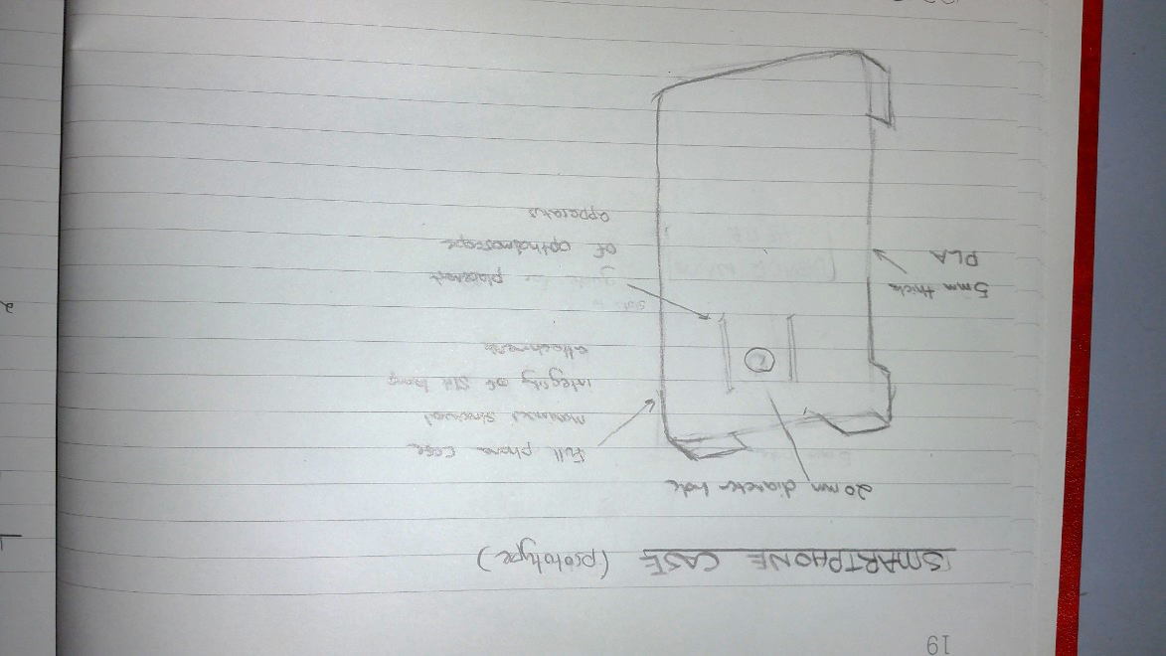Using a full size smartphone case to attach the ophthalmoscope apparatus, interchangeable lenses, and slit lamp attachments to the smartphone camera has several benefits:

* Provides sufficient structural integrity to support potentially heavy components.
* Minimises likelihood of user error in using the device.
* Minimises variability in the images, resulting in improved image classification.
* Easy to attach device.

In the first prototype, the ophthalmoscope will friction fit to the smartphone case using small slots in the case (and protrusions in the ophthalmoscope apparatus). In the final version, we can find a better method.

### Ophthalmoscope Apparatus

The opthalmoscope apparatus will initially be separate to the case, so we can iterate on them separate and alternate between different people’s phones.

The opthalmoscope apparatus has essentially has 4 components:

* 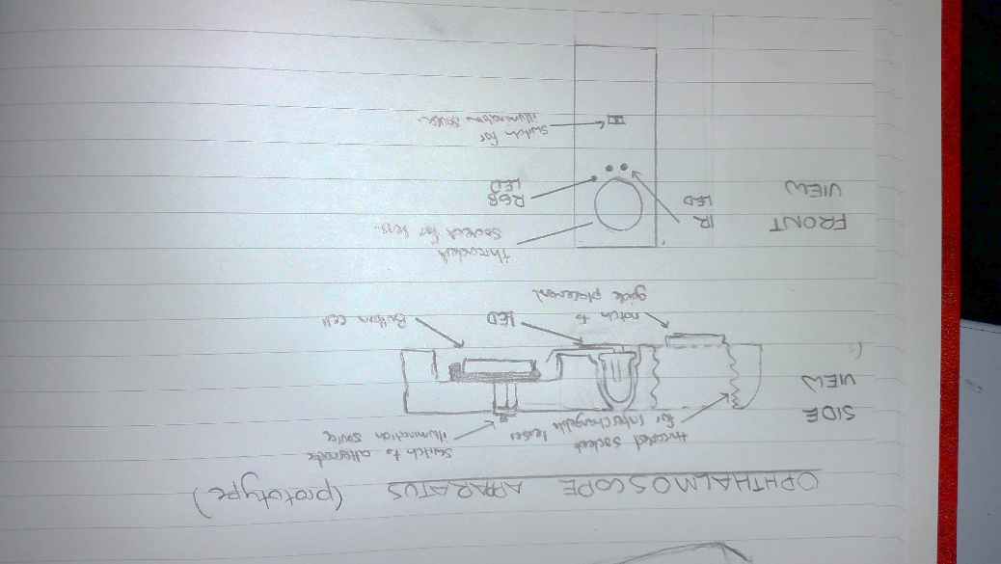A threaded socket for the interchangeable lenses (enables us to quickly change lenses & change the distance between the camera and lense without varying re-modelling the entire opthalmoscope apparatus.
* RGB LED & IR LED within tight sockets (painted with reflective paint) to maximise collumation of light.
* A socket for the button cell (or microprocessor if necessary).
* A switch or button for changing the light source.

### Interchangable Lenses

The device requires interchangeable lenses for several reasons:

* Allow alternating between opthalmoscope & slip lamp biomicroscopy efficiently.
* So we can change the properties of the lenses quickly during development without requiring changing the entire opthalmoscope appataus (such as changing the distance between the lens & smartphone camera).
* So we can have multiple types of lenses while experimenting.

At least four lenses will be initially printed:

1. Lens to mount IOL
2. Lens to mount 20mm (in diameter) convex lens Peter took from telescope.
3. Lens to mount 15mm (diameter) concave lens from smartphone telescope.
4. Lens with only 5mm hole.

### Problems with this design

This design has many problems, and is primarily motivated by the urgency to get imaging the retina. Below are some of the problems:

* Current design doesn’t incorporate slit lamp.
* Friction fit between opthalmoscope apparatus and case will be very temperamental.
* Smartphone case will take a lot of time to print & will require acetone vapor finishing.
* Insufficient LED collimation.
* IR will be too weak to illuminate fundus.

## [TO DELETE] Note:

* Using digital RGB LED (+ IR LED) means switching between colours is easier, can have both at same time, etc.
* Can you image the optic disk & magnify at 100 microns across?
* <http://www.aoa.org/documents/optometrists/CPG-7.pdf>
* <http://www.thingiverse.com/thing:1669006>
* Very useful explanation of diagnosing uveitis:
  + <https://www.reviewofoptometry.com/ce/the-basics-of-uveitis>
  + Types: Anterior
  + Intermediate uveitis
  + Posterior uveitis
  + Panuveitis